How to do schedule control via PMC-53M’s DO with PecStar
Step 1.
Install the LightingCtrl driver - DrvLightingCtrl.dat & LightingCtrl.dat and the PMC-53M driver – DrvModbus.dat & PMC-53M.dat.
And copy the LightingCtrlSet.exe program to the \Common folder of PecStar iEMS.
Step 2. Configure with PecConfig
Take a PMC-53M V6.0 meter for example.
DO Configuration
- Start PMC Setup.
- Add a site and a device.
- Connect the device. Navigate to Setup → I/O Settings, and the I/O Settings window appears. Set DO1 Pulse Width to 0.
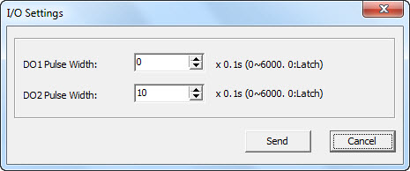.0
- Exit PMC Setup.

In PecConfig
- Start PecConfig.
- For PMC-53M meter:
- Add a site and a device for the PMC-53M matches with the communication parameters.
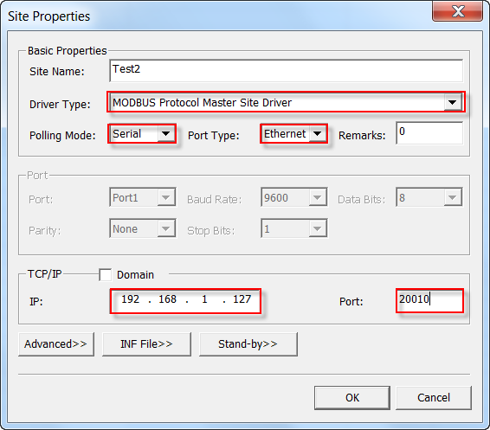
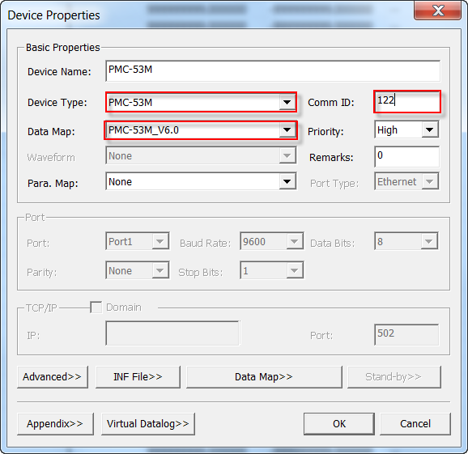
Then the default .snf file is imported. There are two DOs are included in the .snf file:
D16=DO1
D17=DO2
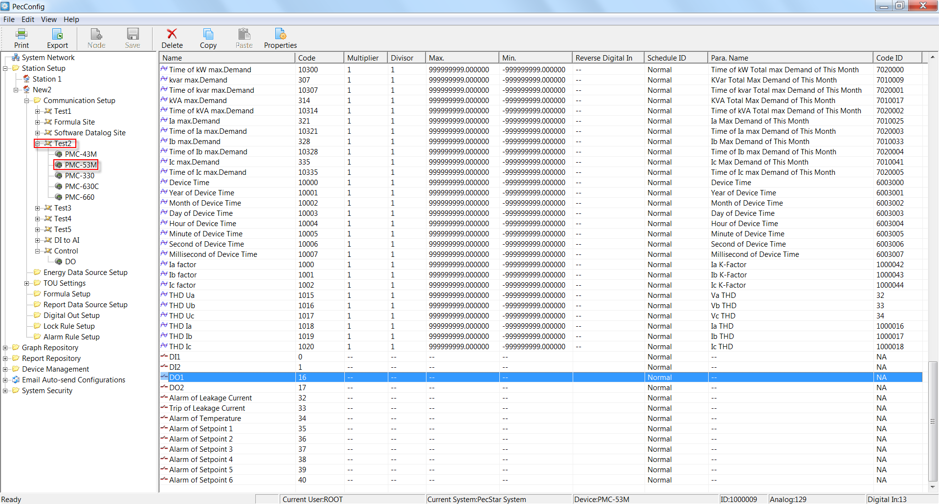
- Add a Digital Out data source. Right-click on the Digital Out Setup folder from the left-hand pane and select New…
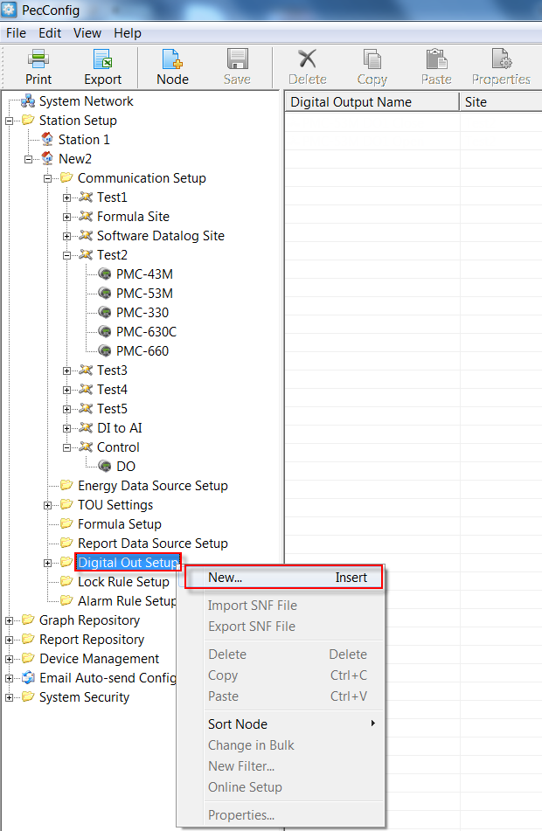
- The Digital Out Properties dialog box appears.
- Enter a name in the Name box for identification.
- Set Site and Device as per the system to locate the meter.
- Set Code to 0. For DO1, the code is 0. For DO2, the code is 1. The code is defined by the communication driver.
- Set Type to Open.
- Set Add in Bulk to 1. The value specifies the number of pairs of the DO control data sources. If the value is 1, a pair of DO control data source will be added, which type is set to Open and Close respectively.
Then click OK.
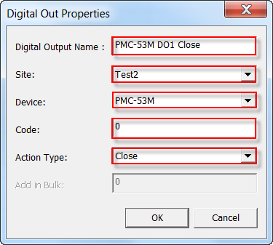
- The pair of DO control data source is listed at the bottom of the right-hand pane. Double-click on the last digital out data source and change its name for identification. As below:
- Save the configuration to database.

- For LightingCtrl driver
- Add a virtual site. Enter Site Name, and set Driver Type to Lighting Control Site Driver. Leave other settings as default.
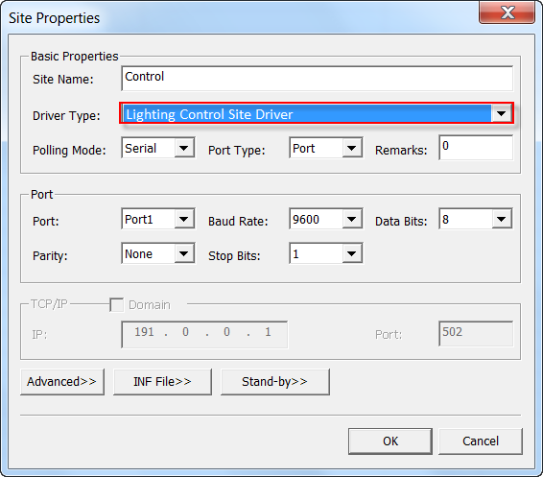
- Add a virtual device. Enter Device Name, and set Device Type to LightingCtrl. Leave other settings as default.
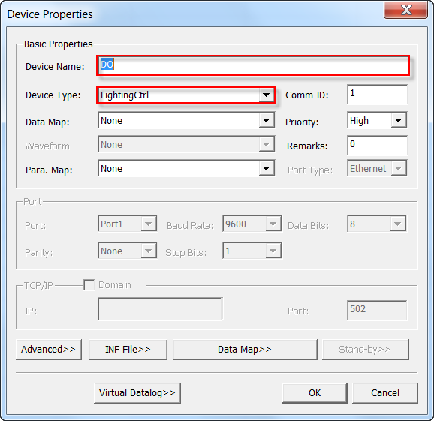
- Add an analog data point. Enter Name and set Code to 0. This data point is used for manual control mode.
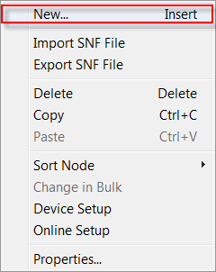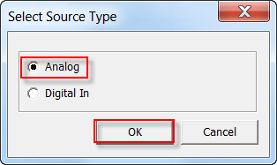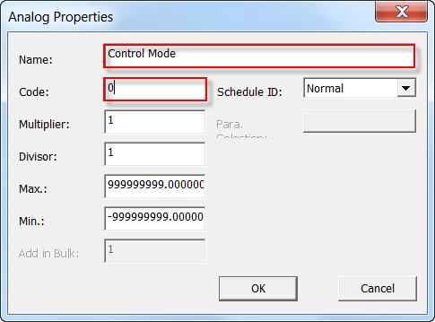

Performing DO Control in Communications Station
- Start Communications Station.
- Right-click on the site and select Launch or Quit Online from the pop-up menu. Leave all real sites offline, and then take the real PMC site online.
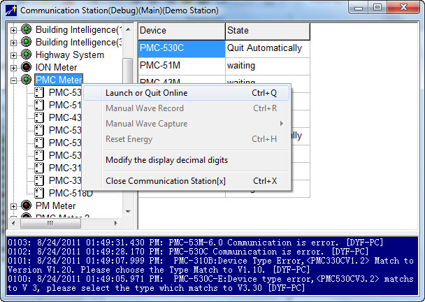

- Start PecConfig.
- Add the PMC-53M meter as he communication parameters.
- Then the default .snf file is imported. There are two DOs are included in the .snf file:
D16=DO1
D17=DO2
- Add a virtual site.

